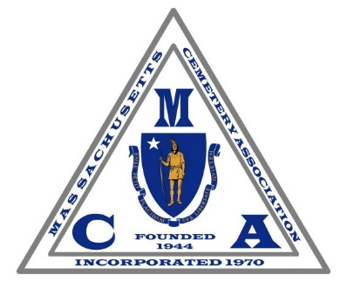
Massachusetts Cemetery Association
Annual Meeting & Educational Seminar
Friday, April 4, 2025
Renaissance Patriot Place Hotel
Foxborough, MA

REGISTRATION FORM
Please fax or email this form by Tuesday, April 1st

Registration and Breakfast 8:00 – 9:00 am
Business Meeting and Speakers 9:00 – 1:00 pm
Buffet Lunch and Networking 1:00 pm

Cemetery/Municipality/Supplier:_______________________________________________________________

Attendee(s):__________________________________________________________________________________________________________________________________________________________________________

Email(s):__________________________________________________________________________________

Member Price #________ x $100.00 ea._________
Non-Member Price #________ x $125.00 ea._________
Sponsorship level: (Please see pg. 2) _________
Supplier Member Display Table # ________ x $150.00 ea._________
(Registration Required to reserve a table, we have a capacity of 19)
Total Submitted: _________

If you have not renewed your 2025 dues, please complete the forms found at:
https://macemetery.org/become-a-member

Please Remit Payments to: Please Send Forms to:
Massachusetts Cemetery Association Fax: (617) 387-0695
P.O. Box 588 Email: ggustafson@woodlawncemetery.com
Revere, MA 02151

LEVELS OF SPONSORSHIP

- Guest Speakers Two Openings $1000.00 Each
- Lunch Table Four Openings $500.00 Each
- Breakfast Table Six Openings $300.00 Each
- Program Six Openings $200.00 Each
- Friends of MCA 18 Openings $150.00 Each

BENEFITS OF SPONSORSHIP

All sponsors will be listed on the program brochure with the company or cemetery name and logo as well as on the display boards throughout the event. They will also be listed on the MCA’s website.

